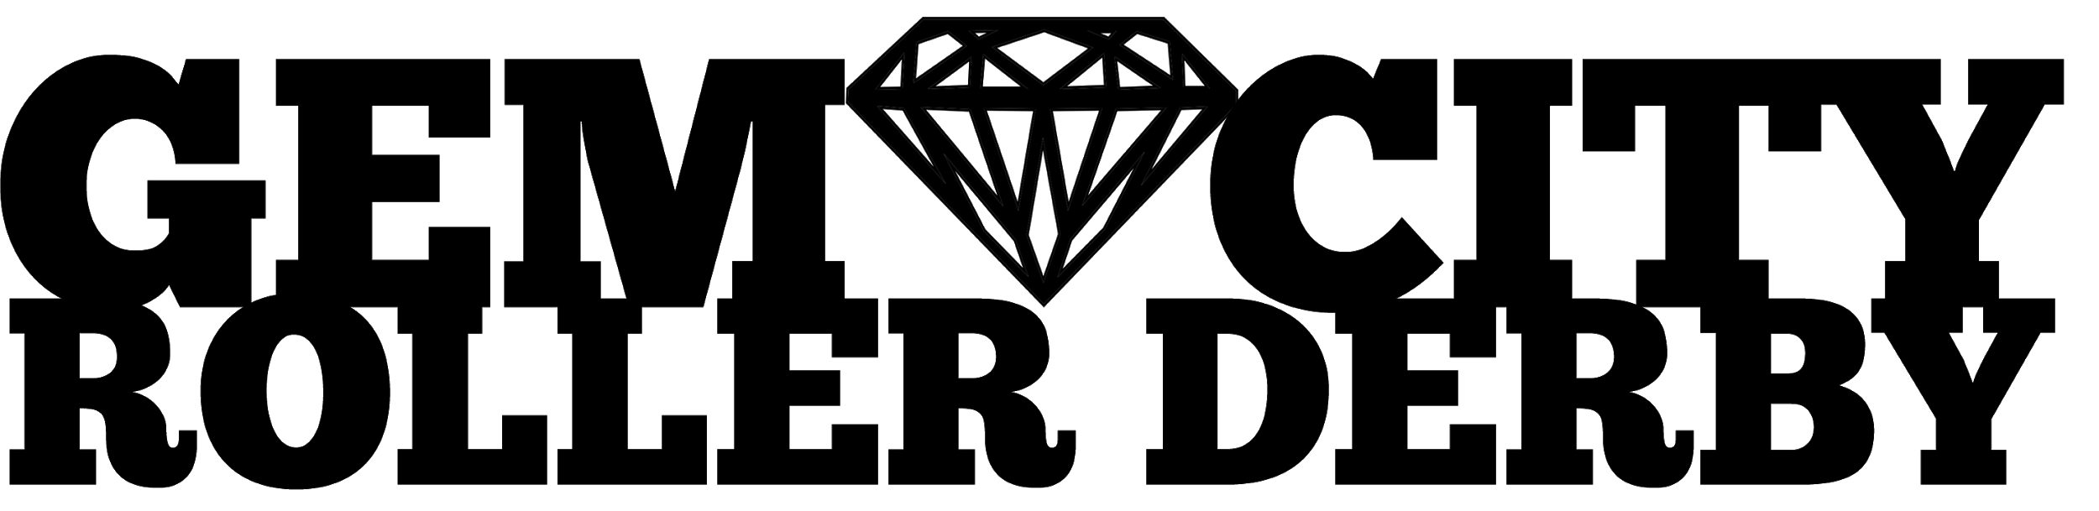

FOR IMMEDIATE RELEASE

WATCH GEM CITY ROLLER DERBY REACH NEW HEIGHTS, SEASON PASSES AVAILABLE NOW

12 February 2020

Did you know that one of the top ranking roller derby leagues in the world is located right here in Dayton, Ohio? As of February 4th, Gem City Roller Derby (GCRD) is ranked 62nd out of over 360 member leagues in the international Women’s Flat Track Derby Association (WFTDA) and 19th out of 159 leagues in the North America East region. In 2019, GCRD reached new heights by representing Dayton, and our city’s #DAYTONSTRONG message, in Pennsylvania at the regional postseason tournament, Continental Cups - North America East. Coming off the successful 2019 season, GCRD is entering 2020 with new opponents, exclusive pricing for Season Passes, and the formal debut of our locally held, WFTDA recognized, Miami Valley OPE!n Tournament!

If you aren’t familiar with flat track roller derby, this fast-paced, action-packed, and family-friendly sport is played on quad skates between locally operated leagues across six continents. Roller derby is unique in that it is one of few contact sports dominated by women.

GCRD’s 2020 schedule is broken into a competitive season and a recreational season, both of which are included in the purchase of a season pass. During our April through June competitive season, GCRD’s three competitive teams will compete at the Montgomery County Fairgrounds’ Event Center. After Gem City’s three competitive teams have faced the world, they will square off against each other for their fall recreational season, competing as three different recreational teams in September through November.

With a season pass, GCRD fans can access any of the 20 games over the seven 2020 home bout dates, including the inaugural Miami Valley OPE!n weekend tournament in June! When fans purchase their passes at GCRD’s Square Store, they will also receive a special gift bag filled with $20 of GCRD merchandise, which they can pick up at the season opener on April 4th. Pass holders also have the exclusive ability to purchase additional adult bout tickets at a 50% discount--$5 instead of $10. There is no limit to how many additional tickets a passholder can buy! Kids ages 7-17 are admitted for $5 each, while kids ages 6 and under are free.

Ready to roll with these Gems? Take a look at their 14th competitive season and 6th recreational season schedules.

2020 Competitive Season Home Bout Schedule
A level game: GCRD’s Purple Reign vs Columbus’ All Stars - April 4th
B level game: GCRD’s Violet Femmes vs Columbus’ Gang Green - April 4th
C level game: GCRD’s Lavender Haze vs Windsor ON’s Windsor ASalts - April 4th
B level game: GCRD’s Violet Femmes vs Eerie PA’s All Stars - May 16th
C level game: GCRD’s Lavender Haze vs Eerie PA’s Zom-Bs - May 16th
ABC level 12-game tournament: Miami Valley OPE!n - June 6th & 7th

2020 Recreational Season Schedule
GCRD’s Snark Attack vs GCRD’s Bully Frogs - September 26th
GCRD’s Bully Frogs vs GCRD’s Murder Squad - October 17th
GCRD’s Murder Squad vs GCRD’s Snark Attack - November 7th

Follow GCRD on Facebook and other social media to access the most current schedules.

Can’t make a game but want to support this league of extraordinary women and locals? Become a sponsor, community partner, or vendor at a specific home bout! Visit www.gemcityrollerderby.com/contact for more information. Tax deductable donations are also accepted through the GCRD Square Store and PayPal, both accessible through www.gemcityrollerderby.com Gem City Roller Derby is a skater-owned and operated non-profit. All funds raised go directly toward supporting the league and the local community.

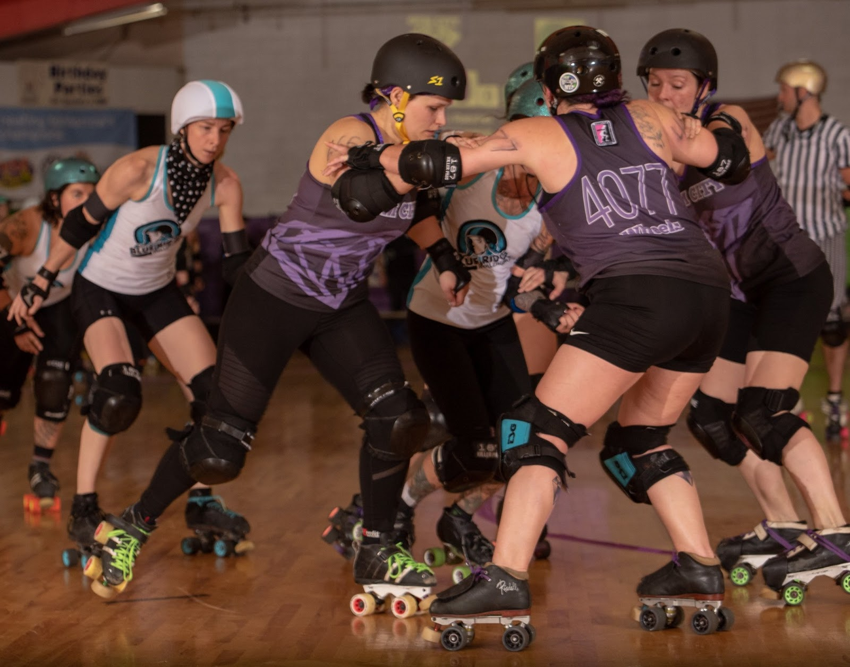
Photo by local photographer Chris Baker

Contact Kristina “Ruthless Skater Ginsburg” Coen to schedule an interview with members of Gem City Roller Derby at gcrd.prmedia@gmail.com.

Gem City Roller Derby (GCRD), established in 2006, is Dayton’s premier women’s flat track roller derby league and a registered 501c3 non-profit athletic organization. GCRD is a member of the Women’s Flat Track Derby Association (WFTDA).

Interested skaters, officials, volunteers, and fans can reach GCRD through the website, www.gemcityrollerderby.com, and social media accounts like Facebook.com/GemCityRollerDerby.

GCRD Media
Facebook Gem City Roller Derby
Twitter @GemCityRD
Instagram gemcityrollerderby

